Ideation Phase
Define the Problem Statements

Date | 2 febuary 2026
Team ID | LTVIP2026TMIDS64619
Project Name | Advancing nutrition science through geminiai
Maximum Marks | 2 Marks

Customer Problem Statement Template:
Create a problem statement to understand your customer's point of view. The Customer Problem Statement template helps you focus on what matters to create experiences people will love.
A well-articulated customer problem statement allows you and your team to find the ideal solution for the challenges your customers face. Throughout the process, you’ll also be able to empathize with your customers, which helps you better understand how they perceive your product or service.

Reference: https://miro.com/templates/customer-problem-statement/
Example:

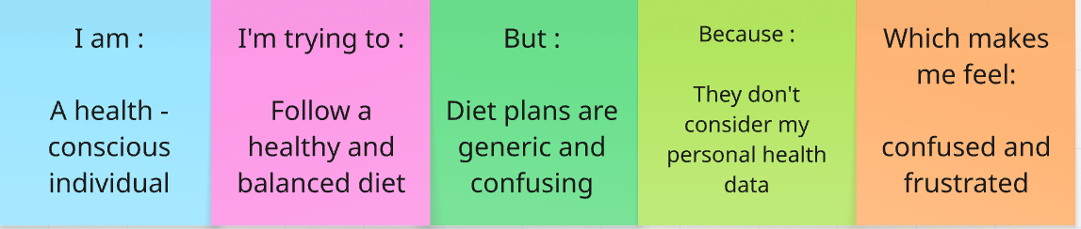
Problem Statement (PS) | I am (Customer) | I’m trying to | But | Because | Which makes me feel
PS-1 | A health –conscious individual | Follow a healthy and balanced diet | Diet plans are generic and confusing | They don’t consider my personal health data | Confused and frustrated
PS-2 | A person with dietary needs | Improve my health through proper nutrition | I don’t get personalized nutrition guidance | Existing systems lack AI- based analysis | Worried about my health

